Date last revised: August 20, 2014

How Population Aging Affects the Macroeconomy

Ronald Lee
Departments of Demography and Economics
University of California
2232 Piedmont Ave
Berkeley, CA 94720
E-mail: rlee@demog.berkeley.edu

Key words: population aging, macroeconomic, intergenerational transfer, demographic transition, old age, support system, support ratio, asset income

This paper was prepared for the Panel on Demographics of the Jackson Hole Economic Policy Symposium on Re-Evaluating Labor Market Dynamics, sponsored by the Kansas City Federal Reserve Bank. Research for this paper was funded by a grant from the National Institutes on Aging, NIA R37 AG025247. I am grateful to all the members of National Transfer Accounts (NTA) country teams for use of their data, to Gretchen Donehower for assistance and to Andy Mason for our ongoing collaboration in this area. The NTA researchers are identified and more detailed information is available on the NTA website: www.ntaccounts.org.

How Population Aging Affects the Macroeconomy

Ronald Lee, University of California, Berkeley

Abstract
Population aging is inevitable and in most of the world either is occurring now or will be soon. In most rich industrial economies, the elderly consume much more than younger adults and earn much less due to early retirement. For this reason, a rising ratio of elderly to the working age population puts pressure on public and private support systems. Support ratios are projected to decline at .3 to .8 per cent per year through mid-century, constricting funds available for consumption, saving, or human capital investment. In countries where the gap between consumption and earning at older ages is filled mainly by asset income rather than public or private transfers, the support ratio exaggerates the impact of population aging. A more appropriate measure takes elder asset income into account and shows a smaller impact in the US, Mexico, UK, S. Korea, Thailand, India and the Philippines. In countries with heavy reliance on public and private transfers, such as Sweden, Austria, Hungary, Slovenia, Germany, Brazil, Costa Rica or Peru, the two measures show the same impact. Many other factors not discussed here could potentially moderate the impact of population aging, such as rising human capital investment, improving health and vitality at older ages, an increased age at retirement, increased female labor force participation, and international capital flows. Population aging presents serious challenges but these need not be overwhelming.

Introduction: Population Aging Is Global
As birth rates fall to low levels around the world, the population growth rate slows and elders replace children in the population age distribution. With slower growth of population and labor force, the same saving rate will yield more capital per worker with higher productivity of labor and higher per capita consumption. However, an older population also requires greater support from the working age population through public or family transfers, and this higher support cost reduces per capita consumption. The balance of these two opposing forces – increasing capital intensity and increasing support cost of the elderly – determines the long term effect of population aging on per capita consumption, as Samuelson (1975) explained long ago (see also Deardorff, 1976 and Samuelson, 1976).

On top of the aging effect of low birth rates, rising life expectancy also raises the elderly share of the population and its support costs, but without offsetting increases in capital per worker. Because health and vitality at older ages have been increasing for decades (Sanderson and Scherbov, 2010; National Research Council, 2012), while the physical demands of work are diminished, raising the age at retirement is an appealing response both for individual behavior and public policy. However, the long term trend in the 20th century has been the opposite, a trend that stopped in the 1990s in OECD countries but which has reversed only modestly since then.

It will be helpful to describe briefly how population aging fits into what demographers call the Demographic Transition. The Demographic Transition is the process through which mortality begins to decline from its initially high level, followed typically some decades later by the beginning of fertility decline from its initially high level. During this early phase the population growth rate first rises and then declines, and the share of the population in the working ages first declines and then rises. Inevitably low fertility and mortality lead eventually to population aging as a final outcome. But population aging is substantially delayed, starting decades after fertility begins to fall. Even in Japan, which is currently farthest along in the aging process, aging is still at an early stage. The old age dependency ratio (ratio of population 65 and over to population 20 to 64, or OADR) will be twice as great in 2050 as in 2010, rising from .39 to .78 according to United Nation projections.

The situation differs from country to country, but even countries that are still young today must operate in a context of a global economy in which there is global population aging (Boersch-Supan, 2006). The global average OADR is projected to double between 2010 and 2050. If we weight national populations by their per capita gdp, then the global average OADR is much higher, and it will still nearly double by 2050 (United Nations, 2013, National Research Council, 2012). This change may lead to increased capital intensity of the global economy along with lower interest rates and higher wages than otherwise for all countries with open economies, regardless of their own degree of population aging.

Population aging matters because people of different ages have different needs and abilities. Children require sustenance and human capital investment through expenditures on health and education. Prime age adults produce far more than they consume. The elderly consume but earn little. Children and the elderly require support from prime age adults, and population aging alters the availability of prime age adults relative to children and the elderly. When the population ages, the relative number of elderly rises and of children falls, changing the balance of givers and receivers for public and private and public transfers, and changing the numbers of workers, savers, and holders of cumulated assets. These changes in relative numbers of people with different economic behaviors require adjustments throughout the economy.

Here I will draw on a new source of information, National Transfer Accounts or NTA, to describe economic behavior as it varies by age, and to analyze the mechanisms through which support flows from working age adults to children and the elderly. These mechanisms include public transfers and private transfers as well as saving, investment, and asset income, each with its own age patterns which vary from country to country and region to region. These age patterns of economic behavior then interact with changing population age distributions producing macroeconomic effects (Lee and Mason, 2010). Of course, these initial impacts are not the final economic outcomes, which depend also on individual behavioral responses and public policy responses, eventually leading to a new equilibrium. But assessment of these initial effects is a good place to start.

National Transfer Accounts are consistent with standard National Accounts as formulated by the United Nations System of National Accounts, SNA. However, they go beyond National Accounts in two important ways. First, they add an age dimension to most variables in the accounts such as consumption, labor income, saving, asset income of various kinds, tax payments, and public benefits received. Second, they provide estimates of private transfers made and received, both within households and between households. The methods are described in a Manual published by the United Nations (2012) and results for 23 countries are presented in a book, Lee and Mason (2011), along with comparative analyses. The project, co-directed by Andy Mason and myself, has now grown to include research teams in each of 45 countries, both developed and developing, in Europe, Latin America, North America, Asia, Africa and Oceania. The goal of the project is to describe the flows of resources across ages and generations within economies in order to deepen understanding of the consequences of changing population age distributions for developing countries as they benefit from a high proportion in the working ages and for countries experiencing the challenges of population aging.

National Transfer Accounts Describes Interface of Population and Economy

Balancing equation in words
To understand the way that income flows across ages and generations occur in the economy, consider the budget of an individual. On the one hand, there are inflows both of cash and of goods valued in money terms. These inflows include labor income, asset income, and transfers received from others, both public and private. The outflows include consumption, saving, and transfers given to others, both public and private. The inflows and outflows are equal as an ex post identity.
Outflows
Inflows

Rearranging the terms of this equation, we have:
Life Cycle Deficit

Reallocations

The difference between consumption and labor income is called the life cycle deficit in NTA, which may be positive, negative, or zero. This difference is financed or disposed of through reallocations – the part of asset income that is not saved and net transfers to or from others.

This flow identity holds for every individual, and so it also holds for each age group (the sum of individuals of a given age) and for the total economy. NTA measures the public and private components of each item at each age, and further decomposes each of these components into subcategories.

Measurement of consumption and labor income
It will be useful to start with the NTA concept and measurement of consumption and labor income on the left side of this equation. Consumption by an individual, in NTA, is the sum of private consumption and the cost of publicly provided in-kind transfers received by this individual. Surveys report consumption expenditures for households, so in most cases it is necessary to impute the consumption of the individuals in the household. For private expenditures on health and education it is often possible to make a quite accurate imputation based on information in the survey. For other private consumption, NTA allocates household consumption expenditure in proportion to a set of equivalent adult consumer weights that is the same for every country analyzed (.4 for ages 0-4, rising linearly to 1.0 at age 20, and constant at 1.0 thereafter). A discussion of this method and alternative possibilities, such as Engel’s method or the Rothbarth method, can be found in Deaton (1997) and Lee et al. (2008).

The cost of in-kind public transfers is typically calculated from micro and/or administrative data together with National Accounts aggregates which are allocated to individuals based on their age, enrollment status, survey data on receipt of benefits, and similar information. Typical examples of in-kind public transfers are public education, publicly provided health care and long term care, public housing, and public distributions of food.

Labor income consists of the wages and salaries of employees, plus fringe benefits (including employers’ share of payroll taxes, if any), all before tax. To this is added two thirds of income from reported self-employment and unpaid family labor. The method of allocating unpaid family labor to individuals in the household is described in Lee et al (2008). The actual age profile for labor income is, for each age, the average across all members of the population, male and female, with positive earnings or with zeros. The age profile then reflects, at each age, labor force participation rates, hours worked per participant, and hourly wage or productivity.

In a final step, the age profiles of consumption and labor income are adjusted up or down proportionately so that when multiplied by the population age distribution and summed the totals exactly match the total in National Accounts.

To facilitate the comparison of results across the many countries in NTA, we often divide all profiles for a country by the average level of labor income at ages 30-49. That has been done for the data presented in figures in the remainder of this paper.

Estimated Age Profiles of Consumption and Labor Income for Rich and Developing Nations
Using the methods just described, consumption and labor income by age have been estimated for most of the NTA countries. Figure 1 shows average values for six developing countries and for six rich countries. The expected shape of the economic life cycle is immediately apparent in both rich and developing countries, with low labor income in youth and old age and bell-shaped earnings in between, while consumption is more uniform across the adult life cycle. But important differences are also apparent. In developing countries, labor income is higher in childhood while it peaks at a later age in rich countries, probably reflecting their higher human capital and less physically demanding work. After this peak, labor income falls rapidly and completely in rich countries, due at least in part to the retirement incentives built into public and private pension systems (Gruber and Wise, 1999). Consumption also shows important differences. In childhood the bulge in consumption in the rich countries represents investment in human capital, particularly education. Even more striking is difference in the age pattern of adult consumption. It is flat in developing countries, probably due to extensive co-residence of elderly with their adult children. In many rich nations, however, the age profile of consumption rises strongly with age and the elderly consume far more than younger adults. This is also true for some middle income developing countries with generous public pension systems such as Brazil.

The age profiles of both consumption and labor income make population aging more costly in rich nations than developing countries. On the one hand, in rich countries the elderly consume much more than working age adults. On the other hand, they work less in old age. The net result is that the life cycle deficit in old age is greater in rich than developing nations.

What is the Origin of the Contrasting Age Profiles?
One might well wonder how the age profiles of consumption and labor income came to differ in this way between the rich and developing countries. Might this be a long-standing regional peculiarity of individualistic Europe compared to Asia, for example? Looking at changes over time for these profiles helps to answer these questions.

Figure 2 shows age profiles for US consumption spanning nearly a half century, for 1960, 1981, and 2007 (Lee, Donehower and Miller, 2011). The figure shows the level of total consumption by age and it also shows the main components of consumption, private and public in-kind transfers. The differences are striking. In 1960, total consumption declined strongly after age 60 (in the cross-section). During the 1960s the Medicare and Medicaid programs were created, providing publicly funded health care for the elderly and the poor, respectively. Medicaid has come to be an important funder for long term care of the elderly. Consumption provided by these two programs is indicated by the top segment in the figure. This segment barely existed in 1960, but by 1981 it had grown large enough to make consumption by the elderly tilt upwards. Growth in these program continued and by 2007 they contribute strongly to the steep upward tilt of total consumption by age. From 1960 to 2007 the ratio of consumption by an 80 year old to that of a 20 year old doubled, an extremely important but little known development.

The public transfer programs are not the whole story. The segment just below the top one is private spending on health care, and it also has grown very substantially and contributed to the steep tilt. Note the deep notch in private health spending in 2007 at age 65, showing the substitution of public for private spending at that age of eligibility for Medicare. But even if we focus on “Private Other” consumption, that is private consumption expenditures other than health, education, or housing, we see a rise at older ages. In 1960, Private Other consumption declines after age 60. In 1981 it declines after age 70. And in 2007 it declines after age 80. Perhaps this rise in private consumption spending at older ages reflects the increasing coverage and generosity of Social Security benefits. Finally, it is important to note that public spending on education per child also rose strongly over this period as shown by the growing top segment of the figure at young ages. This is an important part of the story and is a concomitant change in most developing and rich countries as their fertility declines as it did in the US in the years following the peak of the Baby Boom around 1960.

Looking at Figure 2 it is difficult to avoid the conclusion that the growth of public transfers to the elderly, particularly for health care and long term care, has played an important role in raising the consumption of the elderly relative to younger adults. An historical study of NTA age profiles in Sweden has reached a similar conclusion. Data for Japan do not yet have as much historical depth as do US and Swedish data, but changes in Japan from 1984 to 2004 suggest a similar story (Ogawa et al, 2011). Private consumption in 2004 is fairly flat across age, but public in-kind transfers for health and long term care give the consumption age profile a strong upward tilt similar to the US, Sweden and many other rich nations. As public transfers have risen, including cash transfers like public pensions, they have displaced private transfers. In 1984 adult children made net transfers to the elderly above age 60, but by 2004 the elderly up to age 75 are making net transfers to their adult children and grandchildren.

Similarly profound changes in consumption by age have occurred in the US, Sweden and Japan following the growth of the modern welfare state. While I cannot prove that increased public transfers have been the cause of the change, it does seem very likely. Apparently this is not the result of cultural differences among these three continental regions, but (at least so far) seems to be an outgrowth of economic development and the adoption of public transfer programs for the elderly. The move toward these programs is well advanced throughout Latin America even at much lower levels of economic development, and it appears that other East Asian countries such as China, Taiwan and S. Korea, are moving in the same direction.

The age profiles in US consumption shown in Figure 2, and others for intermediate years, can be multiplied by the population age distribution of each year and summed to find total aggregate consumption by the elderly age 65 and above. This aggregate elder consumption can then be expressed as a share of total consumption, which is shown in Figure 3. In 1960 elder consumption was 9.4% of total consumption but this share grew roughly linearly, pausing in the 1990s, to a level of 18.9% in 2011, double the 1960 share. Over this same period, the percentage share of the elderly in the population rose from 9.1% in 1960 to 13.1% in 2010 (, and is projected to rise to 21.4% by 2050 (United Nations, 2014). Evidently both population aging and the tilt in the age profile of consumption contributed to this increased share of aggregate consumption, and the demographic pressures will intensify in the coming decades. If the age profile of consumption has the same shape in 1950 as it does today, then with the projected age distribution of 2050 the elder share of consumption will increase further to 29.8%.

While relative consumption by the elderly has been rising in recent decades, labor supply of the elderly declined. In the US and many European nations, the age at retirement fell by ten or more years from the end of the 19th century to 1990 (Costa, 1998). The reasons are complicated, but during the later decades of that period the strong incentives for early retirement that were built into the benefit structures of public and private pensions played an important role (Gruber and Wise, 1999). However, many governments have reformed their pension systems to reduce these incentives, and more recently retirement ages in many countries have stopped declining and begun to rise, with the OECD average age at retirement up about a year since the 1990s (OECD, 2014), but still well below its level in the 1970s.

There is very substantial variation across NTA countries in labor income by age. One pattern is that in countries where the elderly rely more heavily on asset income to fund their old age net consumption, labor income tends to be higher than in those countries where the elderly rely more heavily on transfers, whether public or private.

The bottom line is that changes in the age profiles of both consumption and labor income in recent decades have raised the life cycle deficit of the elderly substantially, making population aging more costly to society.

Quantifying the Impact of Age Distribution
The “support ratio” is a simple measure that combines the effects of a changing population age distribution operating both through consumption and labor income. To calculate the support ratio we hold the age profiles of consumption and labor income constant at their baseline levels, and multiply them times the population age distribution of some year. Summing these products we find the hypothetical number of workers in that year and the hypothetical number of consumers. The ratio of hypothetical workers to hypothetical consumers is the support ratio. A higher support ratio means that the population age distribution favors labor more than consumption, relaxing the societal budget constraint, while a lower support ratio means that population change has raised consumption relative to labor, tightening the budget constraint. The “fiscal support ratio” is a similar measure based on the age profiles of tax payments and receipt of government benefits.

It is important to realize that these support ratios are derived from age profiles of consumption and labor income for the whole economy, public and private. For this reason, their changes are typically less dramatic than changes in measures of fiscal pressure for very specific government programs for the elderly such as public pensions or public health care.

It is also important to realize that the support ratios are calculated in order to isolate a pure demographic effect on the macroeconomy, not to make an economic projection. A projection would have to take into account the many possible changes in the age profiles themselves due to productivity growth, behavioral changes, economic feedbacks from changes in factor ratios, and so on. It is clear from Figure 2 that the shapes of the age profiles can and do change over time.

For a given level of output per worker, output per hypothetical consumer is proportional to the support ratio:

If the support ratio rises, then other things equal there will be extra output per hypothetical consumer. This could be used to increase saving and investment, to repay government debt, to increase investment in human capital per child (which here is counted as consumption), or to raise ordinary consumption. If population aging leads to a declining support ratio then that same list describes possible ways of reducing costs in the face of the increasing budgetary pressures.

Panel A of Figure 4 plots the support ratios for a few selected developing countries, using the average age profiles shown in Figure 1. We see that in all four developing countries the support ratio initially falls from 1950 to around 1970, or later in the case of Nigeria. This is because improving survival rates for children raise their numbers. Later fertility begins to fall and the support ratio then begins to rise as the share of children in the population drops and the share of working age population rises. This period of increasing support ratios gives rise to the so-called “demographic dividend” in which the growth rate of output per equivalent consumer gets a boost of .2% to .8% per year. In Sub-Saharan Africa the fertility decline and dividend are occurring later than elsewhere, and at a slower pace, as is illustrated by the case of Nigeria. As is suggested by economic theory, the NTA data show that lower fertility is strongly associated with rising public and private human capital investment per child (Lee and Mason, 2012).

Panel B of Figure 4 plots the support ratios for selected rich nations using the corresponding average profile from Figure 1. For these countries the smooth shape of the demographic transition is disrupted by the baby booms that occurred to varying degrees after WWII. However, by now all have begun a period of rapid aging or, in the case of Spain, are just about to. Japan is farthest along in this process, but even Japan still has a long way to go in the aging process, with its old age dependency ratio poised to double between 2010 and 2050. For these countries, the support ratio is falling, subtracting .3 to .7% per year from the growth rate of output per hypothetical consumer from 2010 through 2050.

The US will experience rather modest demographic aging because it has long had somewhat higher fertility than other rich industrial nations, hovering around replacement level (2.0 to 2.1 births per woman) until the recent Great Recession dropped it below 1.9 births per woman, probably temporarily. The US support ratio is projected to decline by about .3% per year through 2050.

What Makes Up the Difference Between Consumption and Earning?
A recurring theme here is the substantial gap between consumption and labor income at younger and older ages in all NTA countries, a gap that has been growing for elders in the US, Sweden, Japan and elsewhere in recent decades. This life cycle deficit or gap exists because there are sources other than labor income to pay for consumption, and we will now consider these sources and their relative importance.

Figure 5 plots the life cycle deficit at each age for the US in 2003, and shows how private transfers, public transfers, and the portion of asset income that is not saved are used to make up the deficit. In childhood and young adulthood up to the age of 25 or so, private transfers from parents are very important, and we see that working age people have negative values meaning that on net they are making transfers to others, in this case their children. As for the elderly, we see that at every age they are also making net transfers to younger family members, in effect to their grandchildren. In addition, children and young adults are the recipients of major public transfers, mainly in the form of public education, jumping when kindergarten begins at age 5. Working age people, starting at age 25, make net transfers through the public sector, meaning that their tax payments exceed the benefits they receive. This continues to be true up until age 65 at which point elders become net recipients of public transfers through Social Security and Medicare. Finally, consider the use of asset income in excess of saving. This begins to be positive in the teen years and becomes an increasingly important way of paying for consumption throughout the remainder of the life cycle. At no age do we see people saving more than they receive in asset income, and bequests, which are not included in this accounting, may be the reason.

The mix of public transfers, private transfers, and asset income less savings varies across the nations and regions of the world, and NTA data allows us to view this variety of mechanisms for providing for old age consumption net of labor income. Figure 6 uses a triangle graph to plot the share of net consumption in old age (the life cycle deficit) that is made-up by each of these three mechanisms. These shares must sum to 1.0. A country in which elder net consumption is financed entirely through asset income less savings would be located at the Assets vertex of the triangle, and similarly for public and private transfers. A country in which elder net consumption was funded half by family transfers and half by public transfers would be located halfway along the line joining the two. A country in which each source funded one third of net consumption would be located at the center of the triangle. Countries in which the elderly make net private transfers to younger family members rather than receiving net support from them have negative private transfer shares and are located outside the triangle, to the right of the line connecting assets and public transfers.

In quite a number of countries the elderly rely almost entirely on public transfers: Sweden, Austria, Hungary, Brazil, and Slovenia. There are no countries in which private transfers account for all support, but in China, Taiwan, S. Korea and Thailand familial transfers are nonetheless important, counting for about 50% in Taiwan and a third in Thailand. Most countries either lie on the Asset-Public transfer line indicating that on net they receive no net transfers (Great Britain, Japan, Slovenia, Costa Rica, Chile, Austria) or they lie beyond it indicating that they actually make net transfers to younger family (Sweden, Brazil, Germany, Peru, Spain, Uruguay, Mexico, India, and the US). Importantly, there are also countries in which elderly rely heavily on asset income: the US, Mexico, Philippines, Thailand and India all use asset income to cover at least two thirds of the gap. Of all the countries included here, only three East Asian countries, China, Taiwan and S. Korea, lie well inside the triangle with all three sources contributing in an important way.

It matters how the old age life cycle deficit is financed. If it is financed entirely by transfers, either public or private, then population aging simply imposes extra support costs on the working age population, costs that must be born either through increased taxes or increased private assistance given to elderly parents and shared with fewer siblings. If, on the other hand, a substantial share of the old age deficit is financed through previously accumulated assets, then population aging may lead to increased assets per capita in the population for purely mechanical compositional reasons. If these assets are invested in the domestic economy then they might raise labor productivity and depress interest rates. If they are instead invested in the international capital market then they will not boost domestic labor productivity and wages but they also will not lead to lower rates of return. Either way, population aging would generate additional asset income, raising National Income, and reducing the support costs of population aging that fall on younger adults.

Are the Elderly Dependent? Redefining the Support Ratio
The elderly are dependents on average only to the extent that they actually depend on others for their support. If the elderly relied entirely on holdings of foreign assets to pay for their consumption, then they could hardly be called dependents even though they might not generate labor income. They are dependent only to the extent that they receive net private and public transfers.

Production depends on both labor and capital. The average working age person brings more labor and less capital to the economy, while the average elderly person brings more capital and less labor. The support ratio (SR) ignores capital and reflects only labor income in relation to consumption. We can construct a new “general support ratio” (GSR) with both hypothetical labor income and hypothetical asset income less savings in the numerator at each age, each calculated from the NTA age profiles by multiplying by the population age distribution in some year and summing.

The general support ratio will differ from the ordinary support ratio only to the extent that asset income less saving plays a role in financing the life cycle deficit. If the deficit is financed completely through public transfers, for example, as was the case for the elderly in five countries shown in Figure 6, then we expect the two support ratios to differ only slightly. However, when people do use asset income to pay for consumption, as in five other countries in Figure 6 including the US, the general support ratio should indicate that population aging will have less severe effects.

The ordinary support ratios and general support ratios for twelve countries are plotted in Figure 7, with both indexed to unity in 2010. For countries shown in which the elderly rely very strongly on public transfers such as Sweden, Hungary, Slovenia, Austria and Finland, the two lines are nearly indistinguishable. But for other countries where the elderly rely heavily on asset income to fund their net consumption, such as the US, S. Korea, Germany, Spain, and Chile, there is a substantial difference. In the case of the US, the impact of population aging is cut by three fourths using the general support ratio. With the GSR the growth of output per hypothetical consumer is reduced by only .06% per year from 2010 to 2050 rather than .26% per year with the ordinary support ratio. One other feature of the GSR is that it suggests a longer and larger demographic dividend as fertility declines in developing countries, because population aging does less to offset the advantages of fewer child dependents.

The key assumption for these results is that the average future adult arrives at old age with the same quantity of assets relative to labor income as in the NTA base year, here 2003 for the US calculation. Of course, there is enormous heterogeneity in asset holdings within most countries, and most retirees may well hold little if any assets.

Conclusions and Policy Responses
Population aging is the inevitable last stage of the demographic transition, and even the currently oldest countries face very substantial aging through midcentury. Population aging in rich industrial countries interacts with increasingly costly life cycle patterns of the elderly who now consume far more than other adults and cease working earlier than in the past. On the consumption side, rising costs of providing health care and long term care play a large role, and it is not clear whether much can or should be done to change that. Nonetheless, policy makers and the public should be aware of these trends and make explicit decisions about the tradeoffs involved, rather than just accepting cost increases imposed by institutions put in place decades ago with consequences that could not then have been foreseen.

Regarding labor supply at older ages there is widespread but not universal agreement by policy makers that retirement ages should be raised. An increase in female labor supply also could help counter the decline in the size of the working age population relative to the elderly. Of course, higher labor supply of the older population and of women comes with a cost in terms of lost production in the home and lost leisure. In addition, differences in health and life expectancy by socioeconomic status mean that later retirement could have regressive effects on pension benefits, unless policy changes are specially designed to avoid this.

Looked at through the lens of the support ratio or the general support ratio, the costs of population aging can be substantial but need not be overwhelming. The greatest impact is on programs and institutions that are focused on the elderly, while the impact on the general economy as measured by these support ratios is an average of parts of the economy that are lightly and heavily affected, and is therefore smaller. It is important that policy makers take a broad view of population aging and its challenges rather than remaining focused on the costs and fiscal stability of programs for public pensions and publicly provided health care.

The point of the earlier discussion about assets and the elderly is not that countries should avoid supporting the elderly through transfers. Pay As You Go public pension systems fill important needs including redistributive support of impoverished elderly, facilitation of intergenerational risk sharing, hedging against stock market or housing value collapse, provision of annuitized income streams, and other purposes as well. The point is rather that a nation with a balanced approach to old age support, relying not only on public transfers but also relying on assets and on increased labor supply at older ages, will have less to fear from population aging.

References
Boersch-Supan, A. (2006) "Demographic Change, Saving and Asset Prices: Theory and Evidence" in C. Kent, A. Park and D. Rees, eds., Demography and Financial Markets (Australian Government, The Treasury), pp.132-165.
Costa, D. L. (1998). The Evolution of Retirement: An American Economic History, 1880-1990. Chicago, The University of Chicago Press.
Deardorff, Alan. (1976). “The Optimum Growth Rate for Population: Comment,” International Economic Review 17 (June), pp. 510-15.
Deaton, A. (1997). The Analysis of Household Surveys: A Microeconomic Approach to Development Policy. Baltimore: Johns Hopkins University Press.
Gruber, J. and D. A. Wise (1999). Introduction and Summary. Social Security and Retirement around the World. J. Gruber and D. A. Wise. Chicago, The University of Chicago Press: 437-474.
Lee, Ronald, Sang-Hyop Lee, and Andrew Mason (2008) “Charting the Economic Life Cycle,” in Population Aging, Human Capital Accumulation, and Productivity Growth, Alexia Prskawetz, David E. Bloom, and Wolfgang Lutz (eds.), a supplement to Population and Development Review. 34(Suppl.): 208-237.
Lee, R., G. Donehower, and T. Miller (2011) “The changing shape of the economic lifecycle in the United States, 1970 to 2003” Chapter 15 in R. Lee and A. Mason (eds.), Population Aging and the Generational Economy: A Global Perspective. Edward Elgar.
Lee, R. and A. Mason (2010) “Some Macroeconomic Aspects of Global Population Aging” in a special supplement to Demography. 47(Suppl): S151-S172.
Lee, R. and A. Mason, principal authors and editors (2011). Population Aging and the Generational Economy: A Global Perspective. Cheltenham, UK, Edward Elgar.
Lee, Ronald and Andrew Mason (2012) “Population Aging, Intergenerational Transfers, and Economic Growth: Asia in a Global Context” in National Research Council of the National Academies. Aging in Asia: Findings from New and Emerging Data Initiatives. Washington, DC: The National Academies Press. http://www.nap.edu/openbook.php?record_id=13361&page=77.
National Research Council (2012) Aging and the Macroeconomy: Long-Term Implications of an Older Population. National Academy Press.
OECD (2014) "Ageing and Employment Policies - Statistics on average effective age of retirement", http://www.oecd.org/els/public-pensions/ageingandemploymentpolicies-statisticsonaverageeffectiveageofretirement.htm, accessed Aug 18, 2014.
Ogawa, Naohiro, Rikiya Matsukura, and Amonthep Chawla (2011) "The elderly as latent assets in aging Japan" Chapter 27 in R. Lee and A. Mason, principal authors and editors, Population Aging and the Generational Economy: A Global Perspective. Cheltenham, UK, Edward Elgar, pp.475-487
Samuelson, P. "The Optimum Growth Rate for Population," International Economic Review, XVI (October, 1975), 531-538.
Samuelson, P. (1976). "The Optimum Growth Rate for Population: Agreement and Evaluations." International Economic Review 17.2 (June), 516-525.
Sanderson, W.C. and S. Scherbov (2010) “Remeasuring Aging” Science 10 September 2010: Vol. 329 no. 5997 pp. 1287-1288 DOI: 10.1126/science.1193647
United Nations Population Division (2012). National Transfer Accounts Manual: Measuring and Analyzing the Generational Economy. New York, United Nations.
United Nations Population Division (2011). World Population Prospects: The 2010 Revision. New York, United Nations.
United Nations Population Division (2013). World Population Prospects: The 2012 Revision. New York, United Nations.

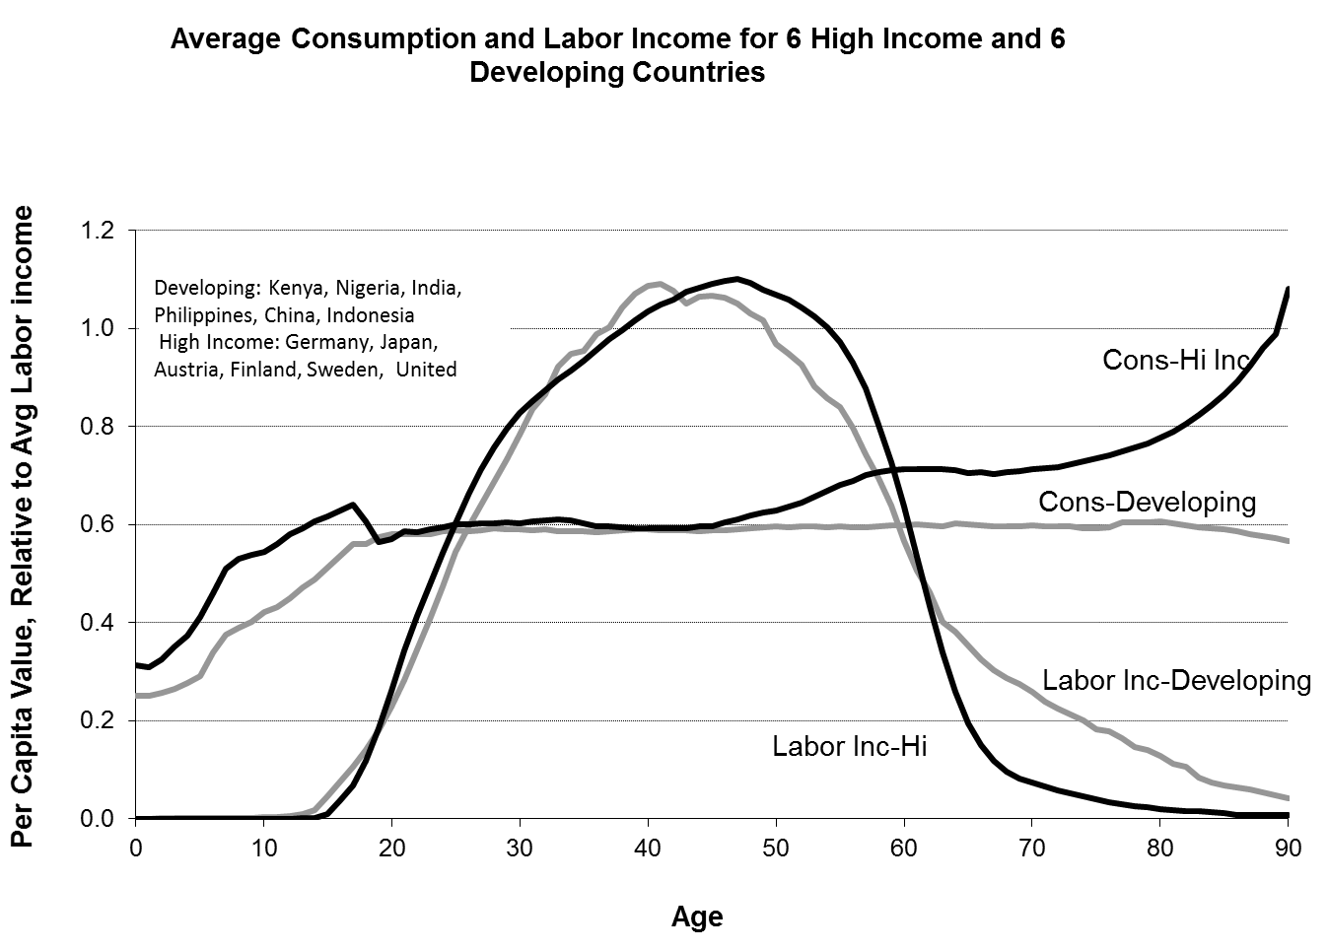
Figure 1. Average Consumption and Labor Income for 6 High Income and 6 Developing Countries
Note: Averages of NTA age profiles for indicated countries. See NTAccounts.org.

Figure 2. Age profile of US consumption and its components for 1960, 1981, and 2007 (ratio to average labor income age 30-49 for each year)

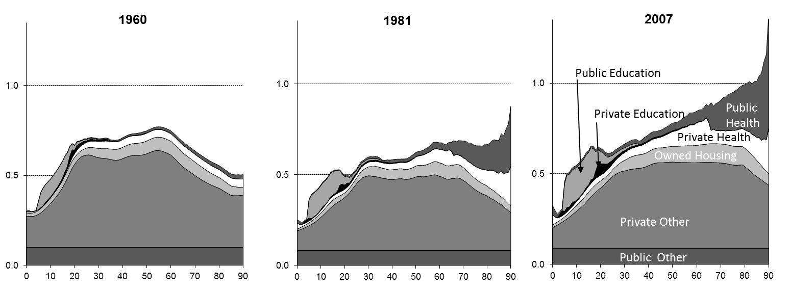

Note: NTA data. See Lee, Donehower and Miller in Lee and Mason (2011).

Figure 3.
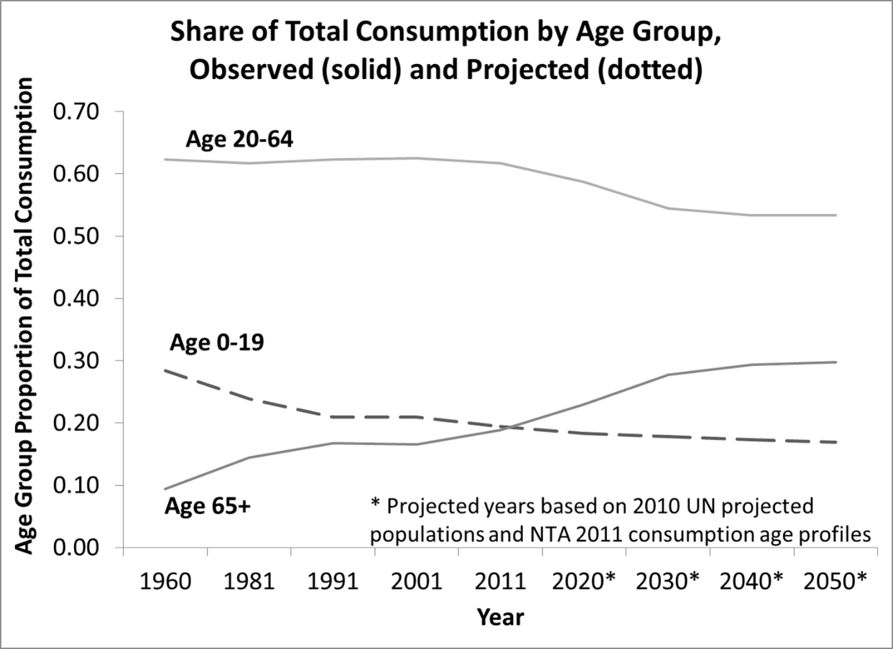

Note: Based on NTA age profiles including those shown in Figure 2, combined with United Nations population projections.

Figure 4. Support ratios based on average age profiles for Developing Countries and Rich Countries and United Nations population projections

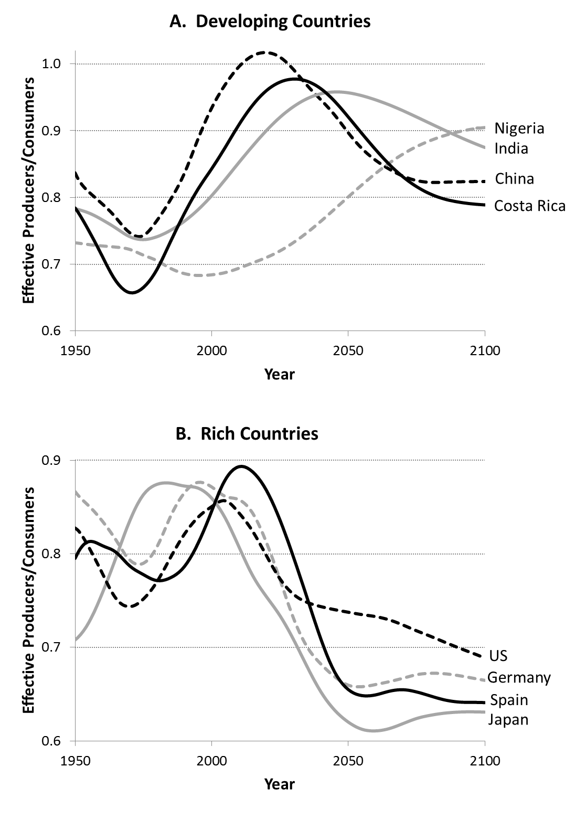
Note: The age profiles used to calculate these support ratios are the averages of those shown in Figure 1. Data are taken from NTA (see NTAccounts.org)..
Figure 5. How the life cycle deficit (consumption minus labor income) is financed at each age in the US in 2007

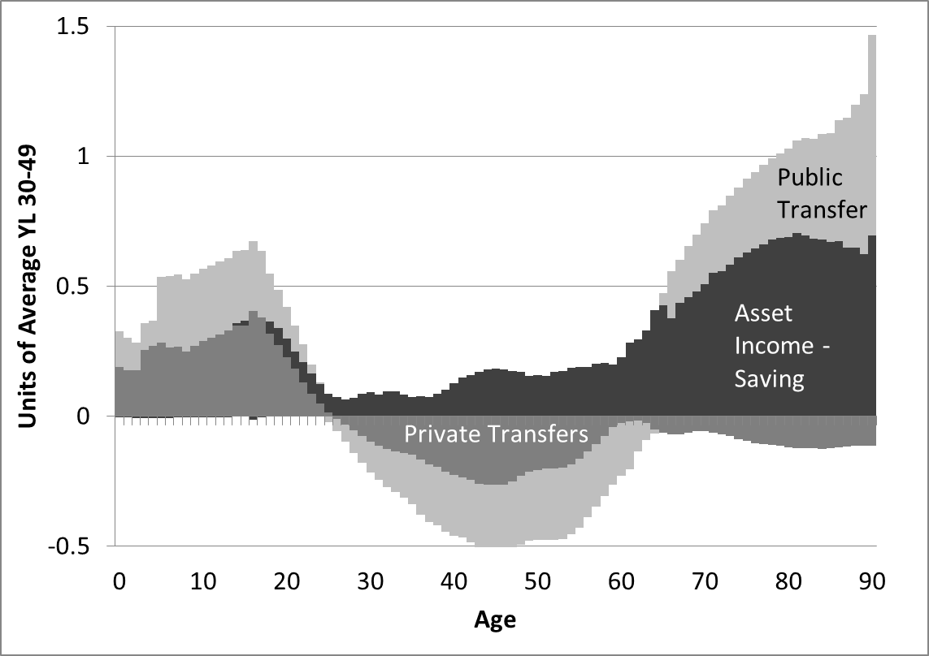

Note: The data are taken from NTA. See Lee, Donehower and Miller in Lee and Mason (2011).

Figure 6. How old age consumption (net of labor income) is funded in NTA countries around the world: share of net consumption funded by asset income, public transfers, and family transfers

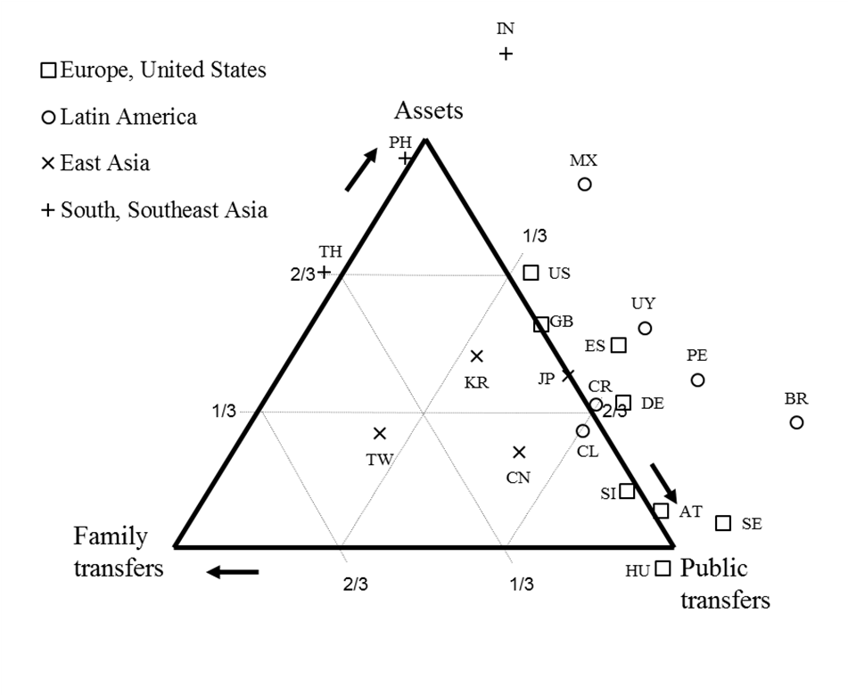
Note: Each data point is a country identified by United Nations 2-letter code. A country at a point of the triangle gets 100% of funding from the labeled source. A country on a side of the triangle gets shared corresponding to distances from the two end points (the closer to end point the greater the share). Countries to the right of the triangle receive negative net familial transfers, that is they make net transfers themselves to younger family.

Figure 7. How the old age support system affects the impact of population aging: Standard support ratios and General Support Ratios (including asset income less savings)

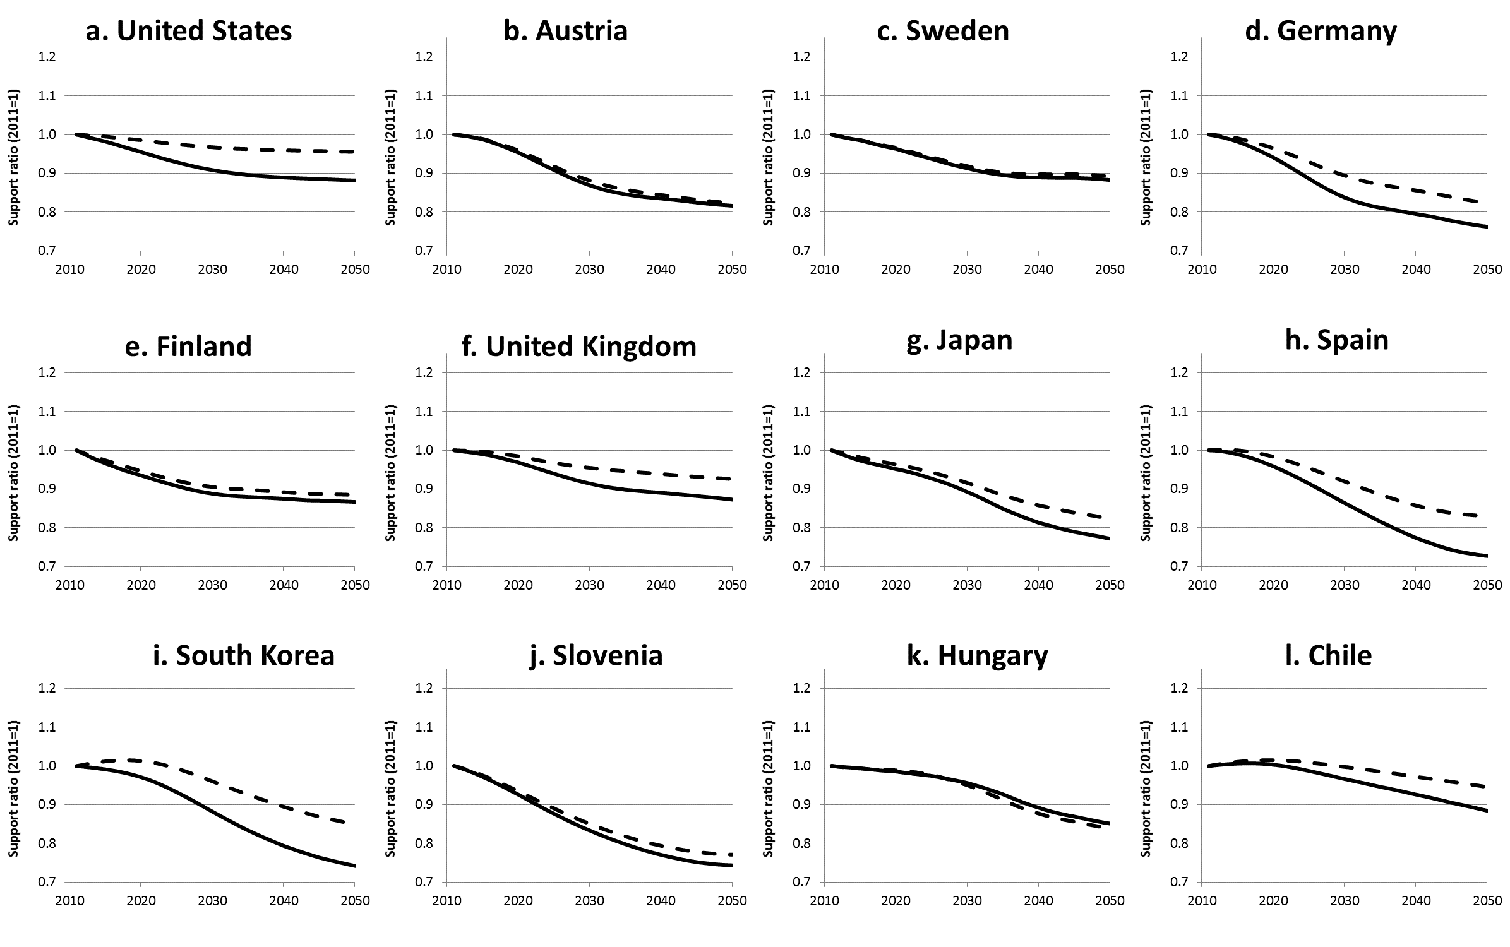

Note: The standard support ratio is the population weighted sum of the baseline labor income age profile divided by a similar sum of the baseline consumption profile. The general support ratio includes in the numerator the similar population weighted sum of the age profile of asset income less saving.

More elaborate methods were tried, drawing on a fairly extensive econometric literature, but we found these unreliable and chose to use this simpler and more transparent method.

